STAR Portal Web Form

Account Management
Under Account Management you can find information on Student referrals: name, contact name, referral status, case status, submission date and link to documentation.
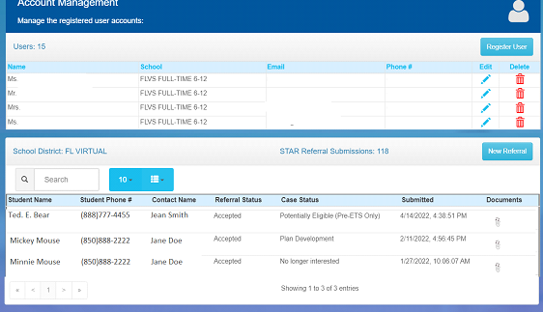

Student/School
On tab 3, select the School District from the drop-down and the most accurate school. School selection is important because VR offices are assigned to specific schools.
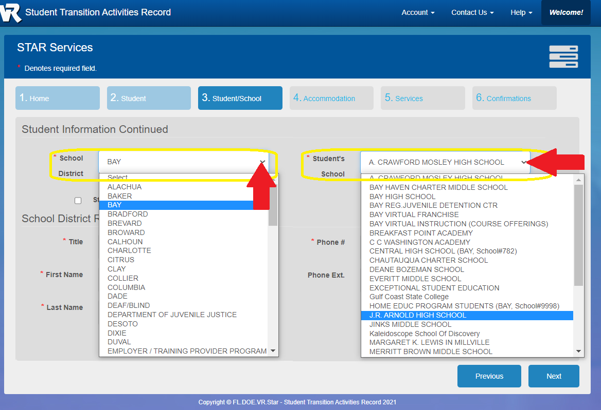

Document Uploading

- On Tab 5, after selecting the services a student is interested in receiving, select the button labeled “+Add a Document”.

- A new window will pop up. Select the “Add Document” button on the top right.

- Another window will open so that you can name the file and select the file to upload. You will name the file, and then select the “Choose File” button. Your computer’s file management window will appear and you will select the file you wish to upload. Once you do this, you will select “Save”

- Once you select “Save,” the “Upload a document” window will close and you will see this screen showing the document as “Pending”:

- Wait until the status indicates “Verified” before selecting the “Close” button.

- Continue on with the referral as prompted to complete and submit.

The Florida Department of Education, Division of Vocational Rehabilitation (VR) is an equal opportunity employer. It is against the law for VR as a recipient of Federal financial assistance to discriminate against any individual in the United States on the basis of race, color, religion, sex, national origin, age, disability, political affiliation or belief. The application process used by VR to determine eligibility for services, any subsequent services and the entire VR process are subject to these non-discrimination requirements. Auxiliary aids and services are available upon request to individuals with disabilities. VR program receives 78.7 percent of its funding through a grant from the U.S. Department of Education. For the 2021 Federal fiscal year, the total amount of grant funds awarded were $176,836,896. The remaining 21.3 percent of the costs ($47,860,557) were funded by Florida State Appropriations. Revised October 2021.

