The purpose of this Programmatic Quick Reference (PQR) guide is to provide instruction for school districts to send a referral to Vocational Rehabilitation (VR) using the Aware Vendor Portal. The Aware Vendor Portal system is a web-based service management application for Vocational Rehabilitation vendors and school districts.

Topic Summary:
This PQR describes how to create a referral in the Aware Vendor Portal system and provides an overview of changes as it relates to the Aware Vendor Portal.

Definition:

Participant – An individual with a documented disability, receiving vocational rehabilitation services in an eligible or potentially eligible status

Student Transition Activities Record (STAR) vs Aware Vendor Portal Cross Functions
STAR | Aware Vendor Portal
Customer/Student | Referral
Deliverable | Documents
Referral (student) | Referral

Steps for completing a School Referral to Vocational Rehabilitation:
Sign In: Your email address is your username.

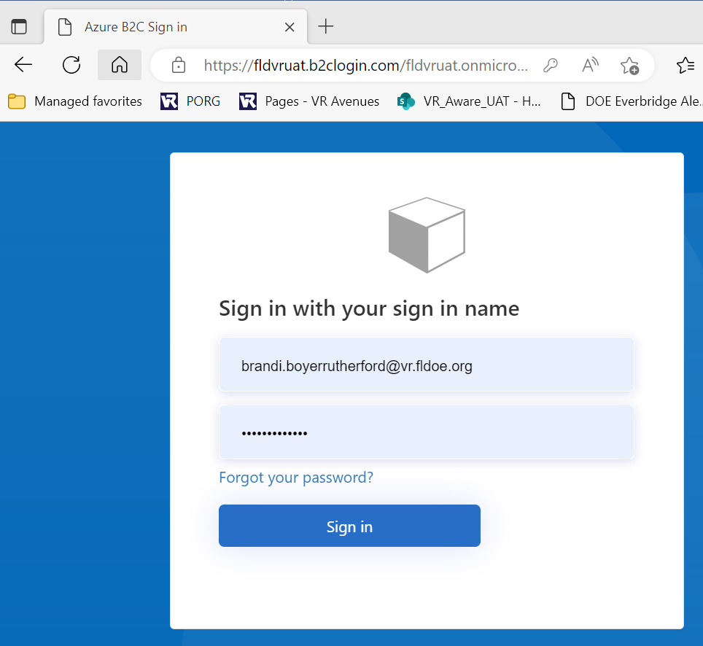

The “Dashboard” will look like this, with your school listed:
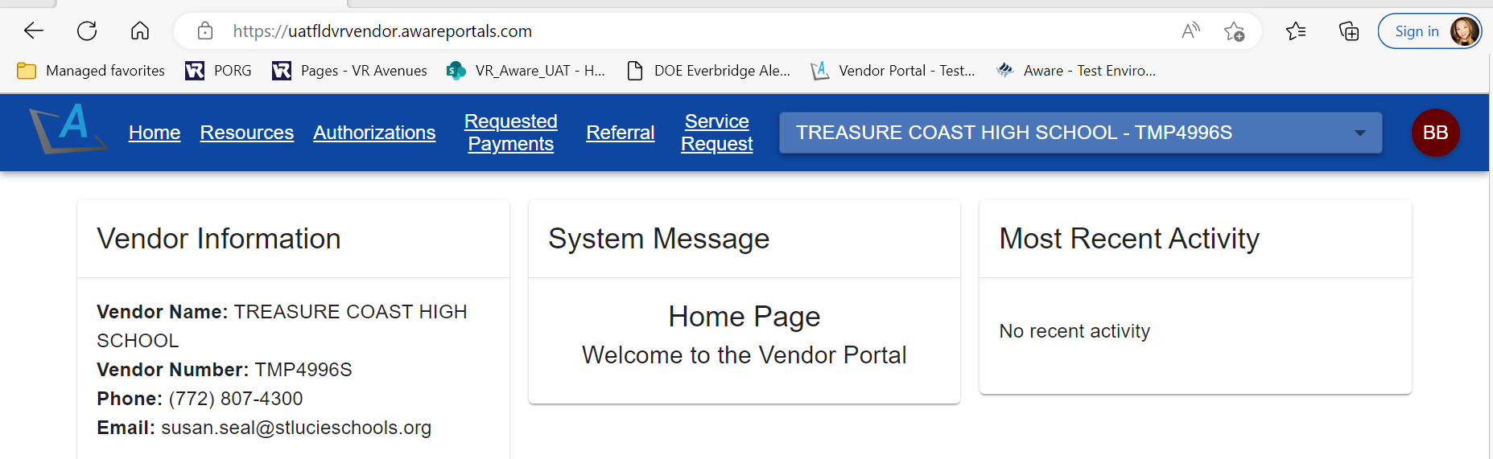
Select “Referral” on the top menu:
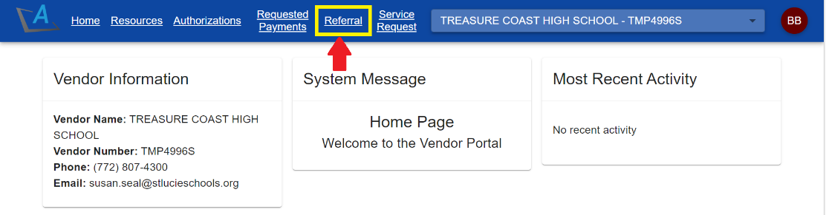
Fill in participant information:
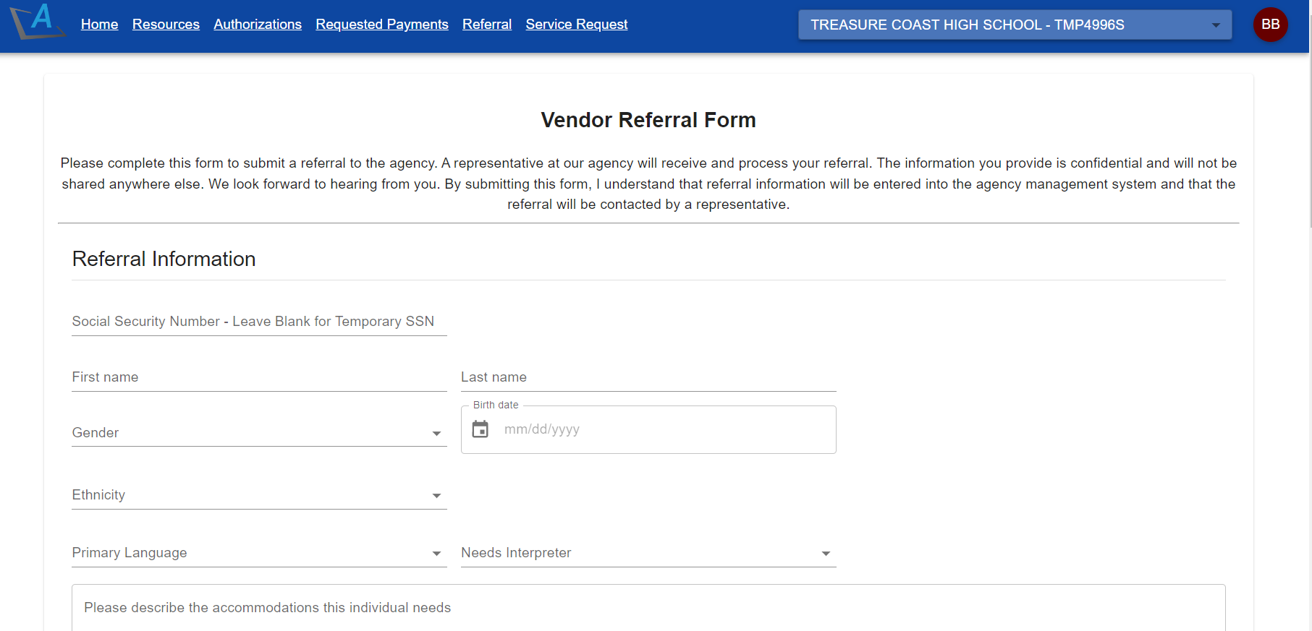

Options to upload attachments and submit the referral:
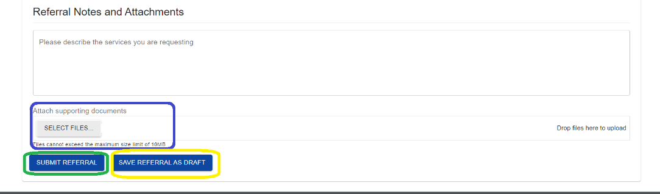

https://www.rehabworks.org/stevens-amendment.html

